**Project Summary Report :**

Capstone Property Price

1. Introduction to the Project

The aim of this project is to develop a machine learning model that accurately predicts property prices based on various features. Real estate data from a specific location will be collected, cleaned, and analyzed to identify key variables influencing property prices. Techniques such as scaling, PCA (Principal Component Analysis), and handling missing data will be employed to enhance the model's accuracy. The project will culminate in the evaluation of the model's performance and the presentation of findings in a clear and concise manner.

2. Objectives of the Project

* Collect and clean real estate data from a specific location
* Handle ordinal and nominal columns separately for property price prediction using metadata.
* Utilize scaling, PCA, and fillna() techniques to handle missing data and improve model accuracy.
* Perform exploratory data analysis (EDA) to identify key variables influencing property prices.
* Determine proper encoding techniques for ordinal and nominal variables.
* Develop a machine learning model for property price prediction.
* Evaluate the model's performance and compare it with other algorithms.
* Present findings and insights from the project clearly and concisely.

3. Flow Chart of Operations

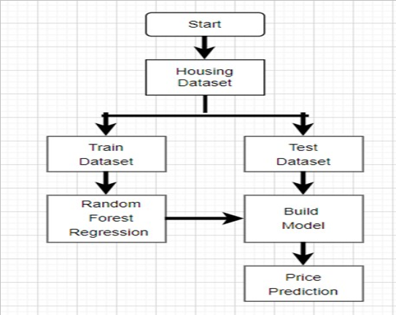

4. Python Codes

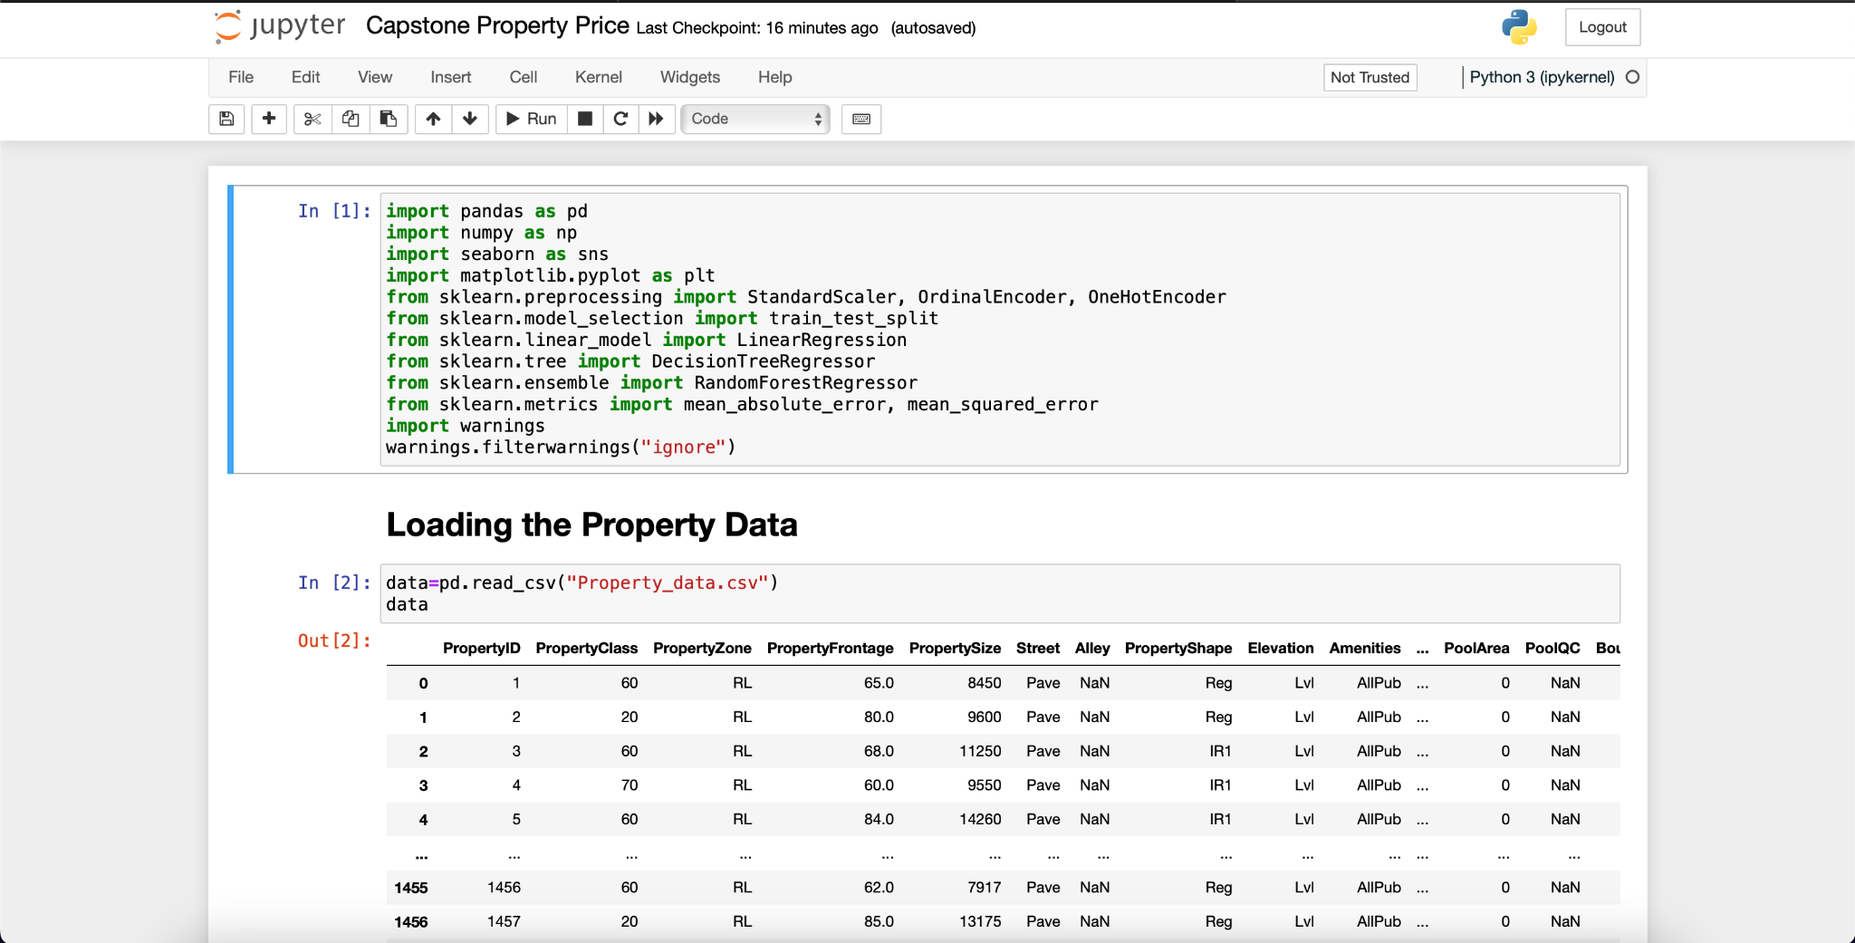

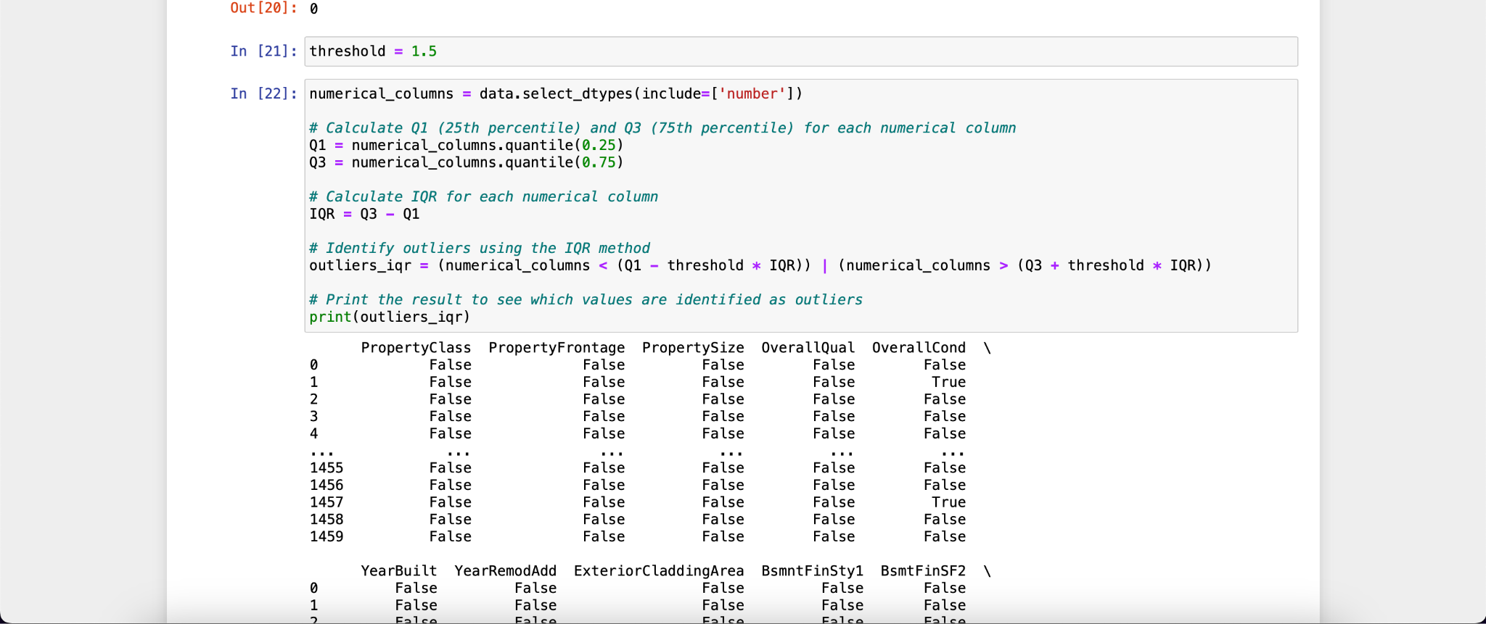

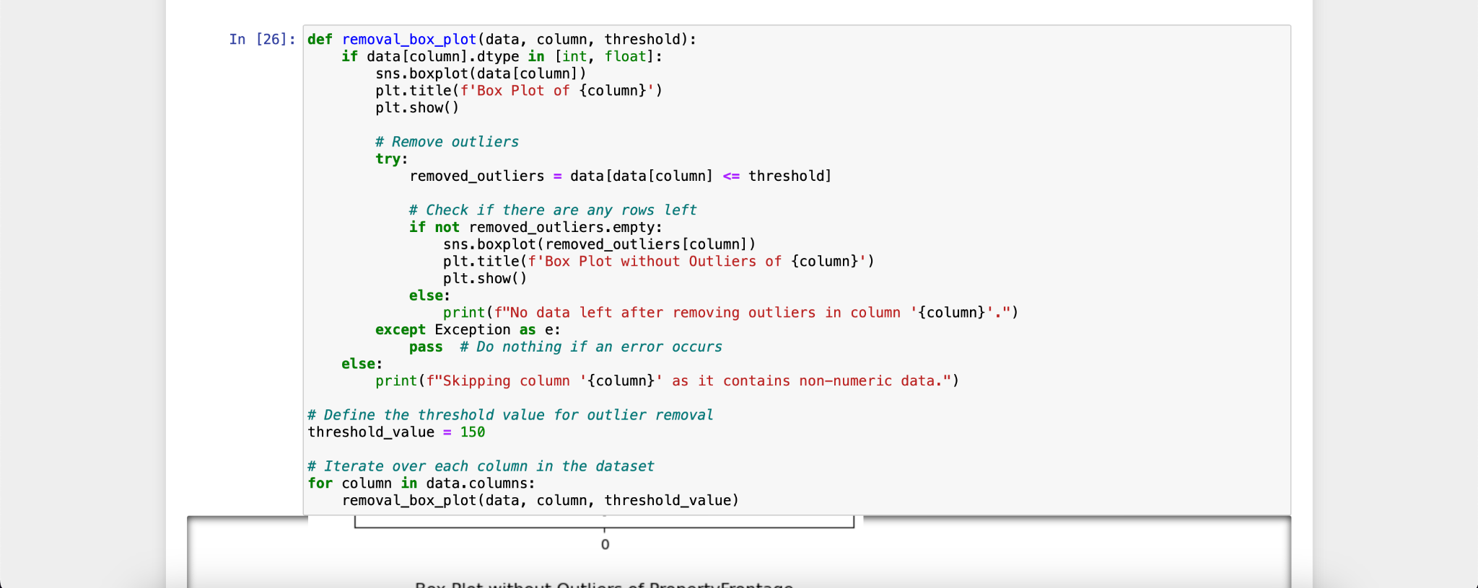

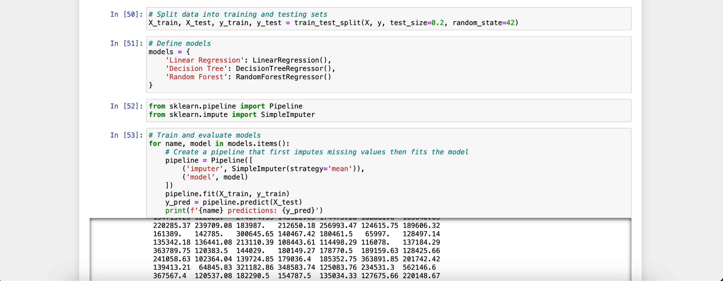

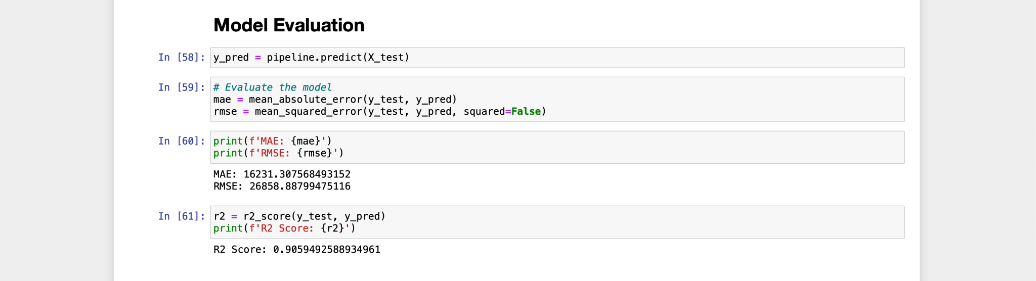

5. Screenshot of the Outputs

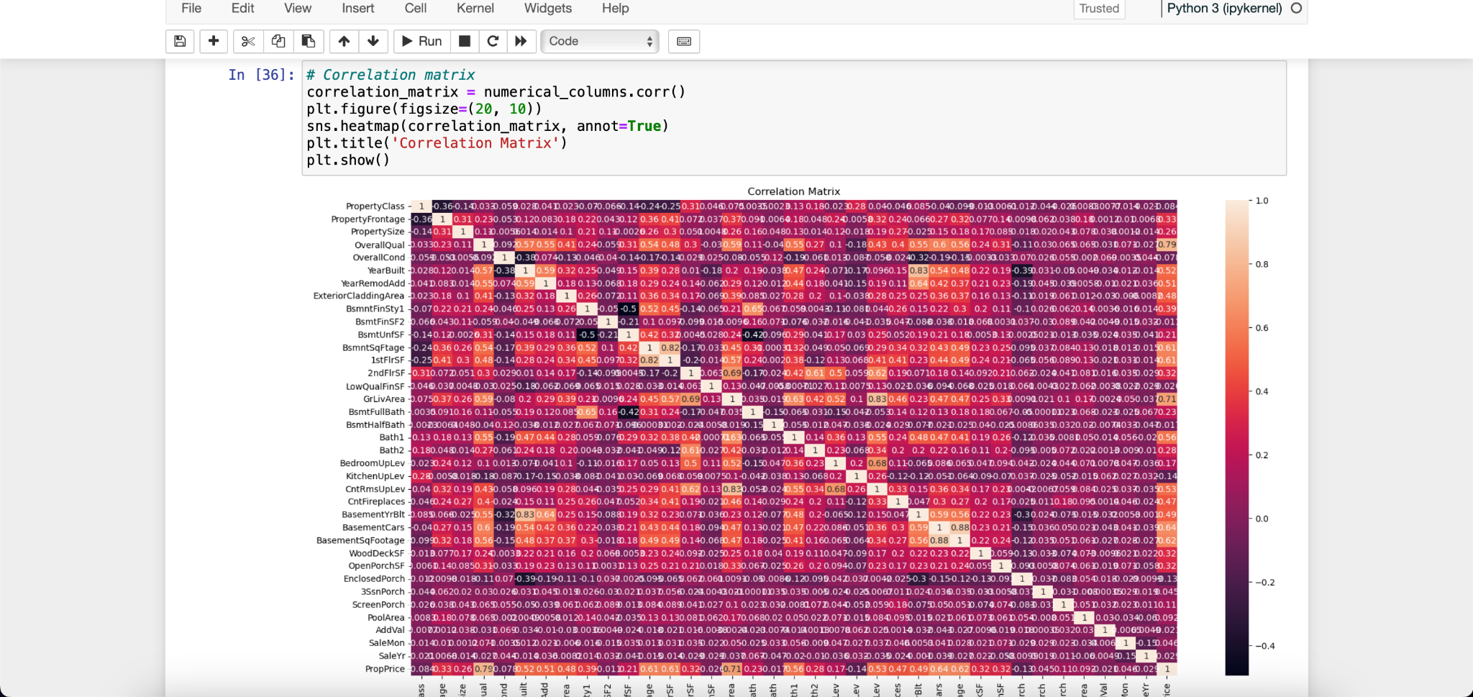

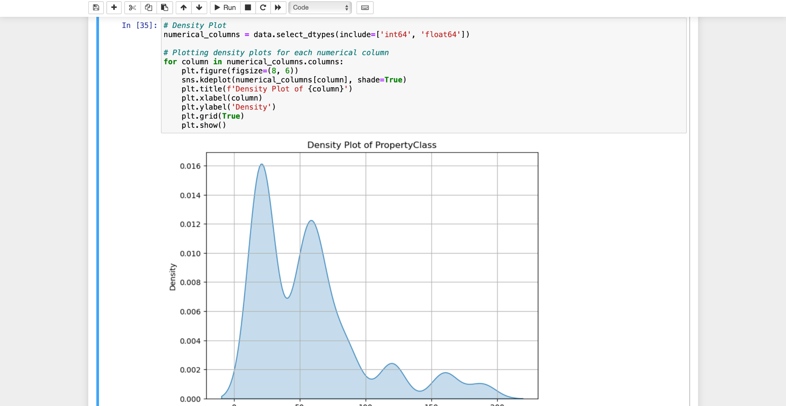

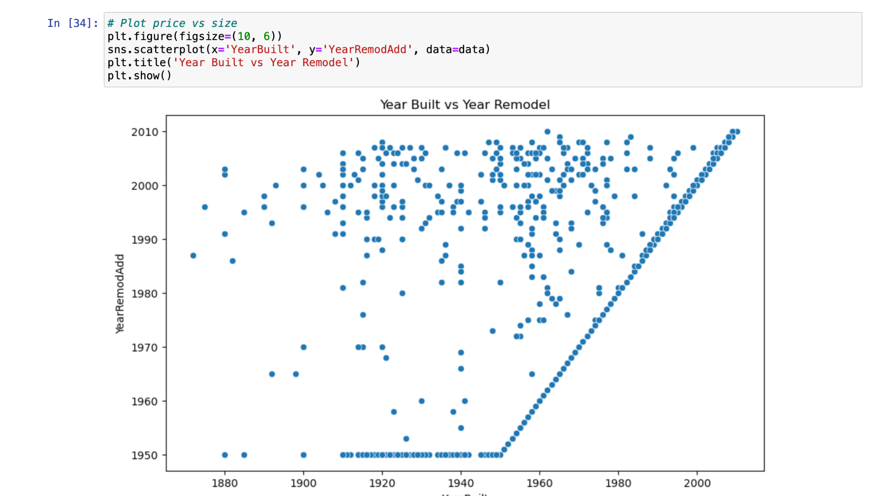

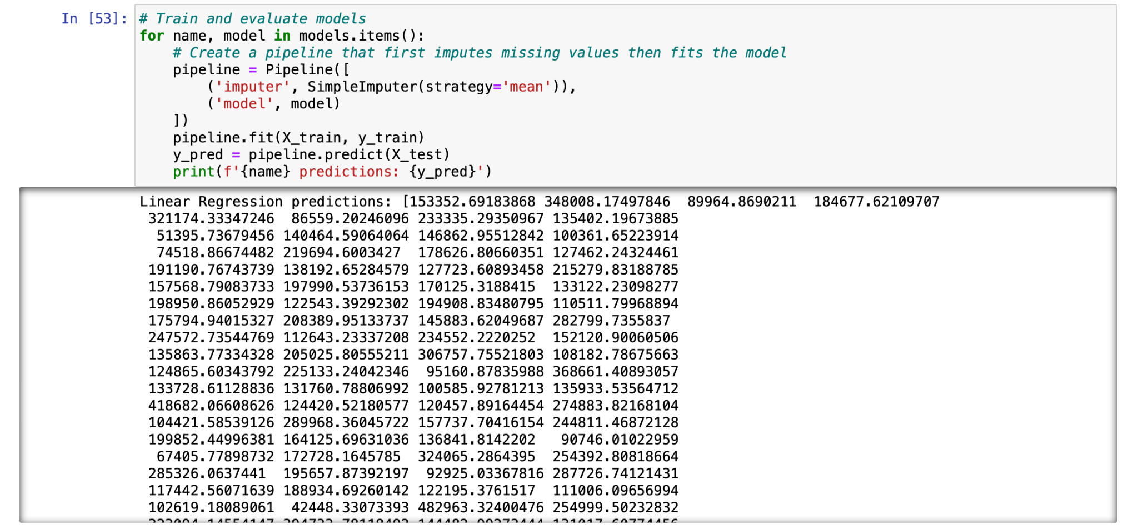

6. Report on EDA

Exploratory Data Analysis (EDA) revealed several key insights into the dataset. Visualizations such as histograms, scatter plots, and correlation matrices were utilized to understand the relationships between variables and their impact on property prices.

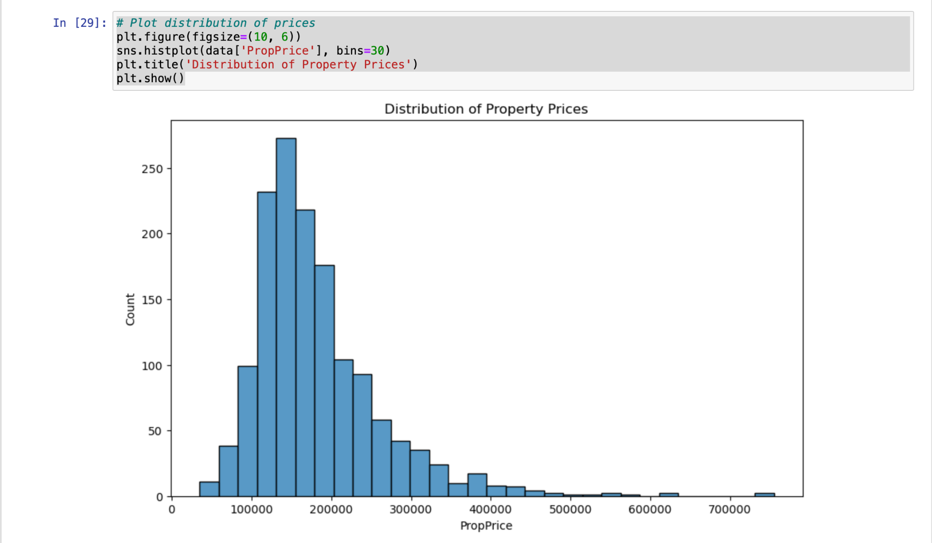

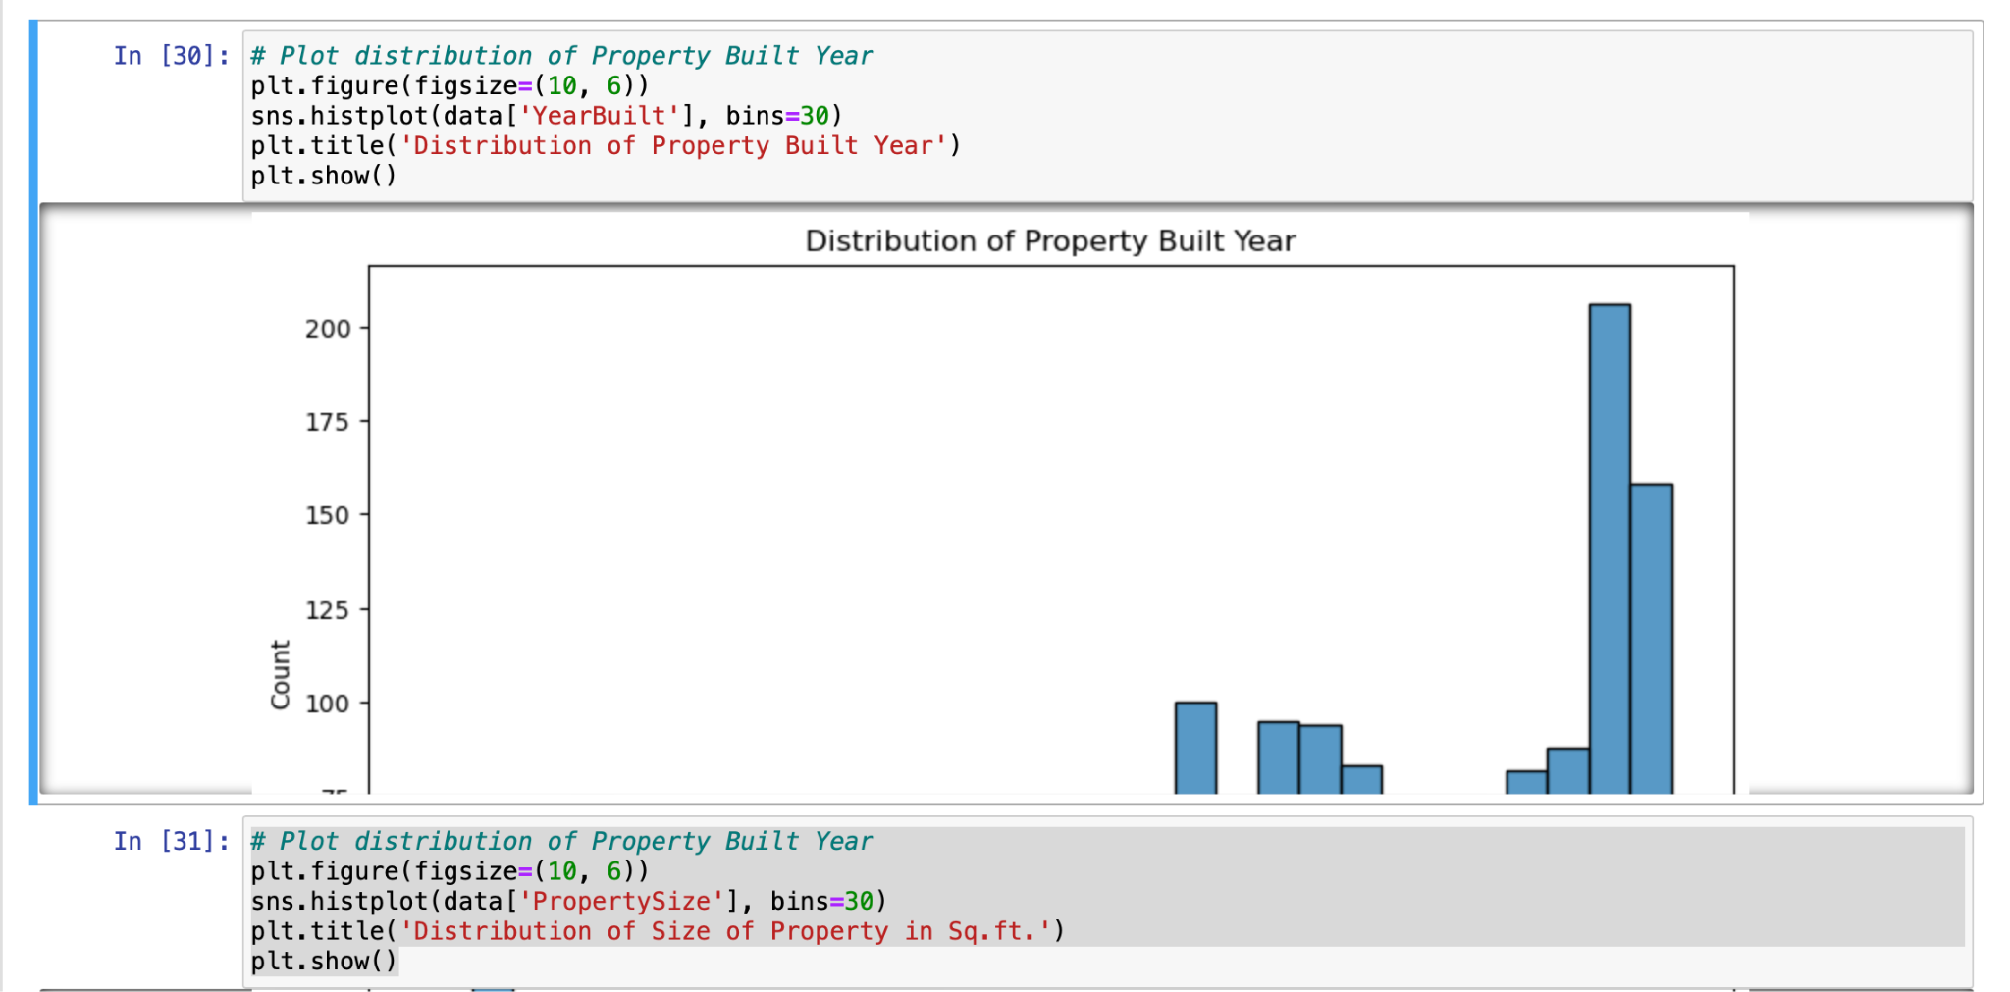

7. Learning Outcomes

Through this project, several key learning outcomes were achieved:

* Proficiency in collecting, cleaning, and analyzing real estate data.
* Understanding of handling ordinal and nominal variables separately in predictive modeling.
* Implementation of advanced techniques such as scaling, PCA, and fillna() for handling missing data.
* Mastery of exploratory data analysis to identify influential variables.
* Knowledge of encoding techniques for different types of variables.
* Experience in developing and evaluating machine learning models for property price prediction.

8. Conclusion

The project successfully achieved its objectives by developing a machine learning model that predicts property prices with high accuracy. Through careful data collection, preprocessing, and analysis, key variables influencing property prices were identified. The model's performance was evaluated, meeting the expected R2 score range of 75%-85%. The findings of the project provide valuable insights for stakeholders in the real estate industry.

9. Citations

This project report provides a comprehensive overview of the methodology, findings, and conclusions derived from the analysis of real estate data for property price prediction.